# iOS Data Access List

1. Offline
   1. Unique ID: vendor + phone ID
   2. Home Address: type
2. Online
   1. GPS
   2. ~~Nearby WiFi~~
   3. Connected WiFi:
      1. **MAC:** 
         1. **only to iOS 13.0 below (not include 13.0, iOS 13.0 or above needs NSHotspotHelper[2] API Access [1])**
         2. **Permit CoreLocation Access: Ok**
      2. **SSID:**
         1. **only to iOS 13.0 below (not include 13.0, iOS 13.0 or above needs NSHotspotHelper[2] API Access [1])**
         2. **Permit CoreLocation Access: Ok**
      3. **RSSI:**
         1. **rough one based on Status bar for non – NSHotspotHelper access**
         2. **accurate one: NSHotspotHelper access**
      4. Connection time
      5. IP
   4. Connection Type: WiFi/Cellular
   5. Cellular:
      1. NPS
      2. Base Station ID: need more research. It’s stored in a sqlite db of iPhone but cannot find a way to get.
      3. ~~BSSS~~
      4. **RSSI:**
         1. **rough one based on Status bar**
         2. **Accurate one: not yet**
   6. Barometer
   7. Magneto
   8. Steps

References:

[1] <https://medium.com/better-programming/how-to-access-wifi-ssid-on-ios-13-using-swift-40c4bba3c81d>

[2] <https://developer.apple.com/documentation/networkextension/nehotspotconfiguration?language=objc>

[3] XCode Configuration:

1. Capabilities:

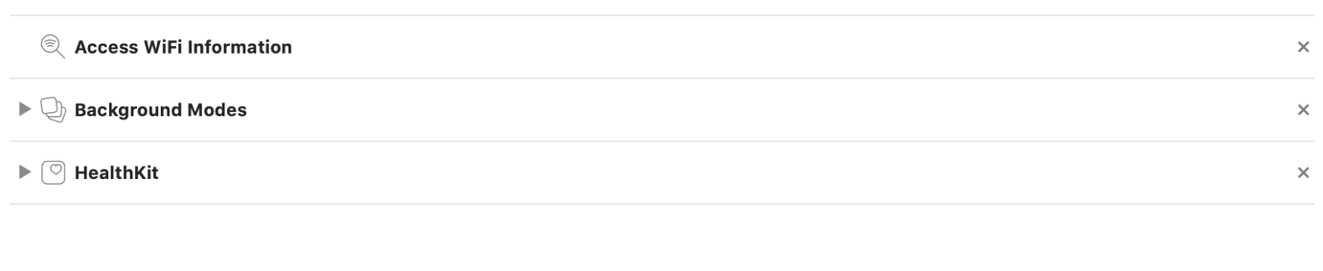

2. info.plist:

